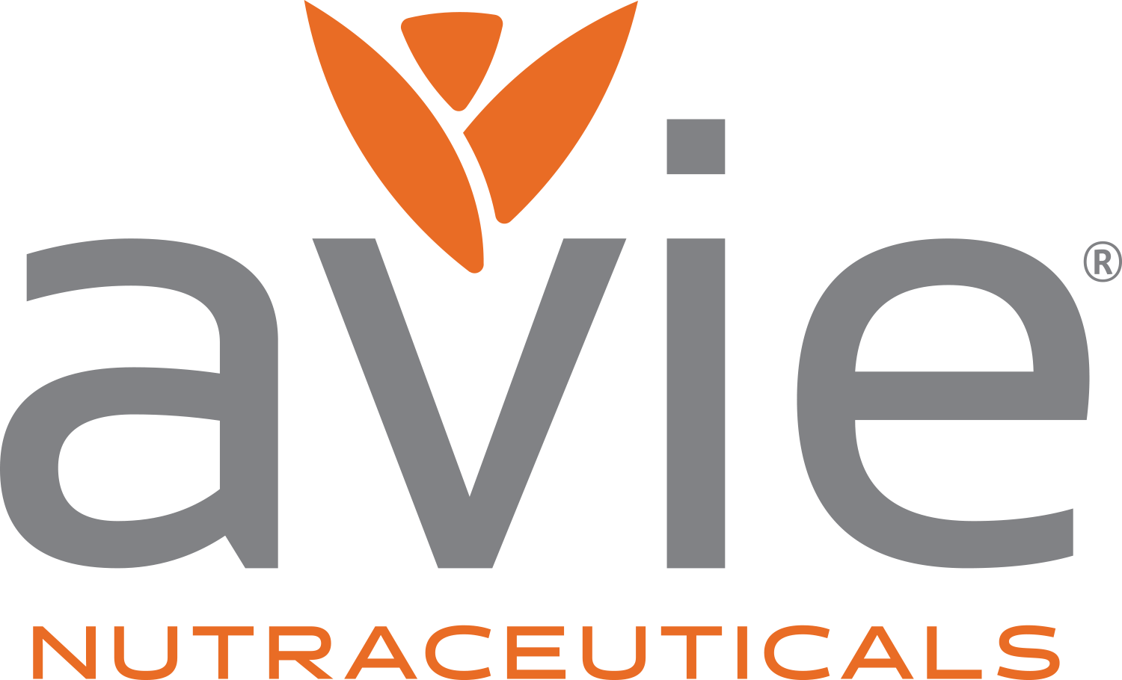

Contact Running Dog LoIC, LLC
Michael Olinde Ron Koliha
Partner, Avie Nutraceuticals Creative Director
Mobile: 225.268.4017 Mobile: 206.369.5665
Toll-free: 844.367.2843 E-mail: http://ron@runningdogads.com
E-mail: http://molinde@avienaturals.com
Avie Nutraceuticals Introduces the Natural Products Industry’s First Non-Staining Curcumin and Menthol Pain Relief Spray

Baton Rouge, LA — July 2017… Avie Naturals is pleased to announce it has begun shipments of a unique topical application for its Curcumin product line. Avie Pain Relief Spray combines non-staining curcumin with menthol to provide both immediate pain relief and inflammation reduction.
This clear spray immediately dries on contact. According to Avie Partner Michael Olinde, this unique Pain Relief Spray helps promote joint mobility and flexibility, and can be especially beneficial for people with sensitivities to NASAIDs such as aspirin, ibuprofen or naproxen.
“With clinical studies showing that Avie’s water-soluble Ultramicronized curcumin capsule formulations may increase the long-established beneficial effects of turmeric extract we are now proud to be the first to bring these same potential benefits to a topical spray”, commented Olinde. “It’s perfect for relieving muscle and joint pain after intense exercise, discomfort caused by arthritis, sprains and bruises, aches from heavy household work or gardening.”
With a suggested retail price of $19, Avie Curcumin Pain Relief Spray joins Avie’s growing family of Ultramicronized Turmeric Curcumin, Joint Relief and Gastrointestinal Balance formulas.
It is available online or through Select Nutrition, Palko Distributors, SuperNatural Distribution and KeHE Distributors.
Avie was founded on the principals of Corporate Social Responsibility (CSR). Our core CSR mission is to provide aid for global relief efforts in developing countries around the world while supporting sustainable agriculture and economic development. To meet our CSR goals, we dedicate 10% of our profits to further our CSR missions. Our board meets regularly to select projects that meet our core criteria and to monitor these initiatives. Avie also encourages our employees to volunteer their time and resources to help people in need and to expand our initiatives.
For additional information, visit www.avienaturals.com.

More… JPEG image attached. High-res and CMYK versions available at www.avienaturals.com/resources
To Opt Out of future mailings, click REPLY, type REMOVE into the Subject line, and send.
# # #
